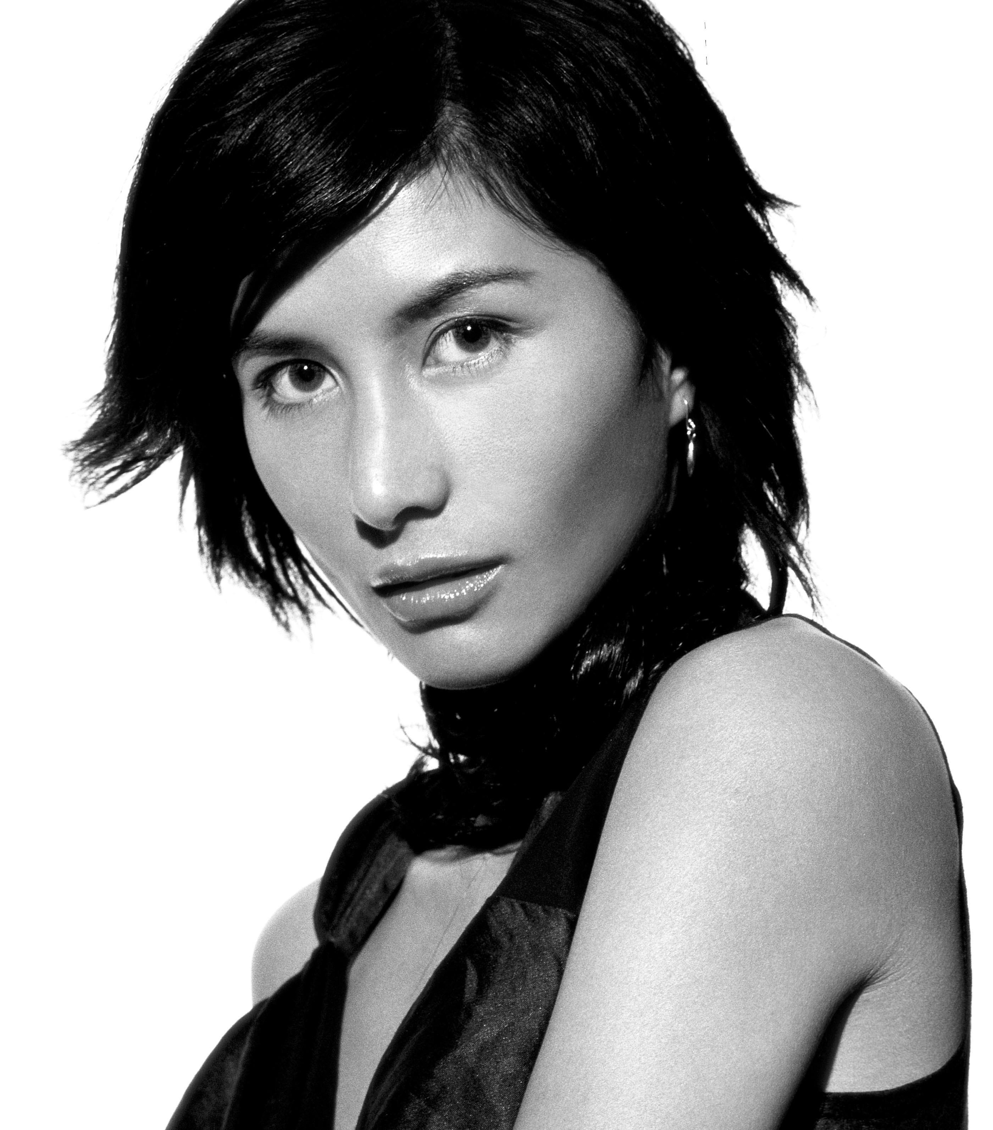

Height: 5’ 3” Weight: 100 lb. Hair: Black Eyes: Brown
Nationalities: Canadian / Hong Kong / Portuguese

FILM AWARDS

2015 The Hong Kong Society of Cinematographers

The Best Charm Actress Award

2014 The TVB Anniversary Awards

The Best Supporting Actress for the TV program “Tomorrow is another day”

2011 The 30th Hong Kong Film Awards

The Best Actress Nominee for the film “Dream Home”

2010 The 43rd The Sitges Film Festival

The Best Actress for the film “Dream Home”

2005 Hong Kong Film Critics Golden Bauhinia Awards

The Best Actress Nominee for the film “Butterfly / Hu Die”

2004 Hong Kong Film Awards

The Best Supporting Actress Winner for the film “Naked Ambition”

2004 Hong Kong Film Awards

The Best Supporting Actress Nominee for the film “Twin Effects”

2004 Hong Kong Film Critics Golden Bauhinia Awards

The Best Supporting Actress Nominee for the film “Naked Ambition”

2002 Hong Kong Film Critics Golden Bauhinia Awards

The Best Supporting Actress Winner for the film “Forever and Ever”

2002 Hong Kong Film Awards

The Best Supporting Actress Nominee for the film “Forever and Ever”

2000 Hong Kong Film Awards

Best Supporting Actress Nominee for the film “Purple Storm”

FILM AWARDS

2000 Taiwan Golden Horse Awards

The Best Supporting Actress Nominee for the film “Purple Storm”

2000 Hong Kong Film Critics Golden Bauhinia Awards

The Best Supporting Actress Nominee for the film “Purple Storm”

THEATER AWARDS

2011 Modern Drama Valley-One Drama Top Life Awards

The Best New Artist Nomination for “The Liaisons”

VOICE COVER FOR ANIMATION AWARDS

2009 Taiwan Golden Bell Awards

The Best Animation Award for the Animation of “LaMB”

MUSIC AWARDS

2015 Metro Radio Mandarin Hits Music Awards
Metro Radio Mandarin Hits Song, Johnny Deep
Metro Radio Album of the Year, The Electrifying Supernatural Lady Land
Metro Radio The Best Asia Rock Band, Josie and the Uni Boys

2015 QQ Music Awards
Creative Premiere Album, The Electrifying Supernatural Lady Land

2009 Taiwan Golden Melody Awards
The Best Music Video Nominee for the song of “Drug to Love”
Produced by Ms. HO Chiu Yee, Josephine, Directed by Mr. Ko Fai

1996 Jade Solid Gold Best Ten Music Awards Presentation
The Best New Artiste – Bronze

1996 Metro Hit Awards
JVC Metro Hit New Female Artiste

1996 RTHK Top 10 Gold Songs Awards
RTHK – The Best New Artiste

OTHER AWARDS

2015 Royal Appointment BY Republic of Montenegro

Lady Josephine Ho Chiu Yee

FILM FESTIVALS

In The Room (2015)  Zhao Wei Films co-produced, Eric Khoo | - The 20th Busan International Film Festival (BIFF) in Korea  - The 63rd San Sebastián International FilmFestival (SSIFF) in Spain  - Singapore International Film Festival 2015  - Hong Kong Asian Film Festival  - The 40thToronto International Film Festival
Full Strike (2015)  852 Films, Dir. Derek Kwok | - The Best Asian Film Award of the 15th Neuchatel International Fantastic Film Festival  - Osaka Asian Film Festival 2015  - The 8th Down Town Taito International Comedy Film Festival  - New York Asian Film Festival 2015  - The 19th Bucheon International Film Festival (BiFan)  - Fantasia International Film Festival 2015  - The 15th Kaohsiung Film Festival  - The 19th Toronto Reel Asian International Film Festival  - The 35th Hong Kong Film Awards
Open Grave (2013)  Atlas Independent, Dir. Gonzalo Lopez-Gallego | - Official fantastic competition of Sitges International Film Festival 2013  - US Tribeca Film Festival 2013  - Lisbon and Estoril Film Festival 2013  - American Film Institute Film Festival 2013
Motorway (2012)  Media Asia Films, Dir. Johnny T | - Opening Film - The 65th Locarno International Film Festival  - Puchon International Fantastic Film Festival  - The 31st Toronto International Film Festival  - The 49th Taiwan Golden Horse Award - Best Action Choreography  - The 19th Hong Kong Film Critics Society Awards  - The 32nd Hong Kong Film Awards

FILM FESTIVALS
Dream Home  Fortissimo Films, Dir. Pang Ho Cheung 2010 | - "The Best Actress" (Josie Ho) - The 43th Sitges Film Festival, Spain  - "The Best Special Makeup Awards" - The 43th Sitges Film Festival, Spain  - "The Best Asian Film Bronze" – The 39th Montreal Fantasia Film Festival 2010  - "The Mad Movie Award" - The 10th Neuchâtel Int'l Fantastic Film Festival, Swiss  - Nominated "The Best Actress" (Josie Ho) – The 30th Hong Kong Film Awards  - Nominated "The Best Visual Effect" – The 47th Taiwan Golden Horse Film Festival  - Nominated "The Best Sound Effect" - The 47th Taiwan Golden Horse Film Festival  - Udine Far East Film Festival 2010, Opening Film  - Amsterdam Cinemasia Film Festival 2010, Opening Film  - France L'etrange Festival 2010, In Competiton  - Pusan Int'l Film Festival 2010, Midnight Passion  - Tribeca Film Festival 2010  - Sydney Film Festival 2010  - Melbourne Int'l Film Festival 2010  - New Zealand Film Festival 2010  - Seattle Int'l Film Festival 2010  - UK Fright Fest 2010  - Sweden Stockholm Film Festival 2010  - Switzerland Neuchatel Film Festival 2010  - Finland Helsinki Film Festival 2010  - Hawaii Int'l Film Festival 2010  - San Sebastian Horror and Fantasy Festival 2010  - Sweden Stockholm International Film Festival 2010  - Tallinn Black Nights Film Festival 2010  - Adelaide Film Festival 2011  - Czech Republic Aerofilms, 2011  - Denmark CPH:PIX 2011  - Turkey Istanbul International Film Festival 2011  - Spain Madrid Fantasy Film Festival 2011  - Spain Syfy Film Festival 2011

FILM FESTIVALS

A Decade of Love International – Segment "Open Rice"  Famous Top Group (HK), Dir. Kung-Lok Lee 2008 | - Cannes Film Festival  - Chicago Film Festival  - Singapore Asian First Films 2008  - The 21st Tokyo International Film Festival  - The 13th Pusan Film Festival
The Drummer  Emperor Multimedia Group, Dir. Kenneth Bi 2007 | - Los Angeles Asian Pacific Film Festival  - Festival del film Locarno 2007  - Munich Film Festival  - Seattle International Film Festival  - Moscow Film Festival  - Asian American International Film Festival  - Sundance Film Festival
Exiled  Media Asia Films, Dir. Johnny To 2006 | - The 63rd Venice Film Festival – In competition  - Toronto Film Festival  - Asian Film Awards 2007  - The 26th Hong Kong Film Awards – Nominated The Best Film
Butterfly / “Hu Die”  Hong Kong Feature Film. – Dir. Yan-yan Mak 2004 | - The 61st Venice Film Festival  - Pusan International Film Festival Official  - India International Film Festival  - Bratislava International Film Festival  - Stockholm International Film Festival  - Sau Paulo International Film Festival  - Tokyo International Film Festival  - Asia Pacific Film Festival  - CinemAsia Film Festival Amsterdam  - The 24th Hong Kong Film Awards

FILM FESTIVALS

Tai Tai  Deansee Films, Dir. Nicholas Chin 2002 | - Cannes Official Selection  - Kodak Asian Vision Award Special Prize  - London Film Festival Official Selection  - Taipei Golden Horse Film Festival – Official Selection  - San Francisco Int’l Asian American Film Festival - Official Selection
Forever & Ever  Hong Kong Feature Film, Dir. Raymond To 2002 | - Berlin Film Festival Official Selection
Dead or Alive Final  Daiei Motion Picture Company, Dir. Takashi Miike 2002 | - Spain Sitges Film Festival  - France L’Étrange Festival  - Poland ERA New Horizons Film Festival  - Locano Film Festival Exhibition
Horror Hotline  Cinefex Workshop, Dir. Poi-Soi Cheang 2002 | - Milan Film Festival Official Selection
Purple Storm  Media Asia Films, Dir. Teddy Chan 2000 | - Taipei Golden Horse Film Festival – Official Selection  - Udine Film Festival – Official Selection
Slow Fade  Rymd Industries, Dir. Daniel Chan 1999 | - Berlin Film Festival Official Selection  - Cannes Film Festival Official Selection  - Cinema Jove Film Festival Official Selection  - Melbourne International Film Festival Official Selection  - Montreal International Film Festival Official Selection  - New York International Film Festival Official Selection  - American International Film Festival Official Selection  - Toronto International Film Festival Official Selection

1995 - 2016: Has acted in over 29 films from Hong Kong & Japan in Lead and Supporting Roles

House of Wolves (2016) Universe Entertainment Limited, Vincent Kok

FULL STRIKE (2015) 852 Films, Dir. Derek Kwok

IN THE ROOM (2015) Zhao Wei Films, Dir. Eric Khoo

THE SEVENTH LIE (2014) Movinpix Co Ltd, Dir. James Hung

NAKED AMBITION 3D (2014) 852 Films, Dir. Kung-Lok Lee

THE APOSTLES (2014) Shanghai Qi Xian Ying Shi, Dir. Renhao Chien

OPEN GRAVE (2013) Atlas Independent, Dir. Gonzalo Lopez-Gallego

COURIER (2013) Arclight Films, Dir. Hany Abu-Assad

BADGES OF FURY (2013) Beijing Enlight Pictures, Dir. Wong Tsz Ming

PORT OF CALL (2012) Mandarin Films Limited, Dir. Yim Ho

MOTORWAY (2012) Media Asia Films, Dir. Johnny To

CONTAGION (2011) Warner Brothers, Dir. Stephen Soderbergh

DREAM HOME (2010) Fortissimo Films, Dir. Pang Ho-Cheung

POKER KING (2009) Sky Films, Dir. Chan Hing Kai, Janet Chun

MURDERER (2009) Edko Films Ltd, Dir. Roy Cheung

LaMB (VO) (2008) Animax, Dir. Ryosuke Tei

Street Fighter -
The Legend of Chun Li (2008) 20th Century Fox, Dir. Andrzej Bartkowiak

1995 – 2016: Has acted in over 29 films from Hong Kong & Japan in Lead and Supporting Roles

A Decade of Love International – Famous Top Group (HK), Dir. Kung-Lok Lee
Segment "Open Rice" (2008)

Kung Fu Panda (VO) (2008) Intercontinental Film, Dir. John Stevenson & Dir. Mark Osborne

The Drummer (2007) Emperor Multimedia Group, Dir. Kenneth Bi

The Simpsons Movie (VO) (2007) Twentieth Century-Fox Film Corporation, Dir. David Silverman

Exiled (2006) Media Asia Films, Dir. Johnny To

Butterfly / “Hu Die” (2004) Hong Kong Feature Film. – Dir. Yan-Yan Mak

Tai Tai (2002) Deansee Films, Dir. Nicholas Chin

Forever & Ever (2002) Hong Kong Feature Film, Dir. Raymond To

Dead or Alive Final (2002) Daiei Motion Picture Company. Dir. Takashi Miike

Horror Hotline (2002) Cinefex Workshop, Dir. Poi-Soi Cheang

Purple Storm (2000) Media Asia Films, Dir. Teddy Chan

Slow Fade (1999) Rymd Industries, Dir. Daniel Chan

TV Drama

TOMORROW IS ANOTHER DAY (2014) Hong Kong TVB, Producer : Lam Chi Wah

THE FUGITIVE PLAN B (2010) Korea KBS2, Dir. Gwak Jeong-hwan

A Road and A Will (1997) Hong Kong TVB, Producer: Amy Wong

The Criminal Investigator II (1996) Hong Kong TVB, Producer: Jonathan Chik

TV/Print Commercial

2015 | Elyze | Hong Kong Spokesman (TVC and Print Ad)
2015 | Skyteam | China and China Spokesman (Online Short Movie)
2015 | Kate Somerville Skin Health Products | Online Promotion Representative
2014 | “World AIDS Day campaign 2014” | Hong Kong Campaign Representative
2014 | Versace Unique Signature Handbags for Pacific Place | Hong Kong Campaign Representative
2014 | King Fook Jwewllery Group | Asian Region Spokesman of King Fook Jew Group (Print Adv)
2013 | Elyze | Hong Kong Spokesman of Elyze (TVC and Print Ad)
2013 | King Fook Jwewllery Group | Asian Region Spokesman of King Fook Jew Group (Print Adv)
2013 | Kagome Juice | Hong Kong Campaign Representative (TVC and Print Ad)
2012 | Leonard | Hong Kong Campaign Representative
2012 | Coach | Hong Kong Campaign Representative
2012 | Shiseido | Hong Kong Campaign Representative
2012 | Alain Philippe Watch | China, Hong Kong & Macau Spokesman (Print Ad)
2012 | King Fook Jwewllery Group | Asian Region Spokesman of King Fook Jew Group (Print Adv)
2011 | Diesel | Fashion label – Diesel Island (Print Ad)
2011 | Yves Saint Lauren (YSL) | Cosmetic – Top Secret Campaign Representative (Print Ad & Online)
2009 | Yves Saint Lauren (YSL) | Cosmetic – Top Secret Campaign Representative
2008 | Alain Philippe Watch | China, Hong Kong & Macau Spokesman
2008 | King Fook Jwewllery Group | Asian Region Spokesman of King Fook Jewellery Group 60th Anniversary (Print Ad)
2007 | Jewelry Manufacturing Association - HK & Macau | Hong Kong, Macau & China Spokesman (Print Ad & TVC)
2007 | Diesel | Feature Star of Diesel (Print Ad)
2007 | ACUPUNCTURE | Spokesman (Print Ad)

TV/Print Commercial

2006 | ESTEE LAUDER | Perfectionist Power Correcting Eye Patch (Print Ad)
2002 | 2 Collection | 2 Collection (Diamond) Hong Kong (Print Ad)
2002 | CUTIS | Cutis Skin Care (Print Ad)
2002 | Wing On Travel | Wing On Travel (TVC)
2002 | Sau San Tong Healthy Trim Institute | Sau San Tong Healthy Trim Institute (TVC & Print Ad)
2001 | BAUHAUS | Bauhaus Clothing & Jeans (Print Ad)
2001 | CARTIER | Image Girl of Cartier (Asia Region) (Print Ad)
2000 | Motorola | Motorola Mobile Phone (TVC)
1999 | Riccola | Riccola Confectionery (TVC & Print Ad)
1993 | Get 27 Mint Liquor | Get 27 Mint Liquor (HK, Taiwan, China) (TVC)
1992 | Whisper | Whisper Sanitary Napkins (HK, Taiwan, China) (TVC)

ALBUM RELEASED

2014 Josie and The Uni Boys – The Electrifying Supernatural Lady Land

2013 Josie and The Uni Boys - “Salute to 80’s”

2011 Josie and The Uni Boys – Third Eye

2008 Elastic Rock

2006 Hell’s Kitchen

- Sickid

- White Lies

1996 Ho Ka Suk Lui

THEATER

Josie Ho has appeared over 5 plays from 1997 to 2011.

2010 The Liaisons, Dir. Frederic Mao
- The 38th Hong Kong Arts Festival
- Expo 2010 Shanghai
- Invited to perform at Beijing People’s Art Theatre
- Invited to perform at Shenzhen Great Theatre

- Perfume, Dir. Terence Cheng

2003 Seventh Heaven, Dir, Kalafina

LANGUAGES

- English
- Mandarin
- Cantonese
- Elementary Japanese
- Elementary Spanish.

CONTACT INFORMATION

Drill Team 162 Limited Unit 05, 7/F, Kai Fuk Industrial Centre
1 Wang Tung Street
Kowloon Bay, Kowloon
Tel: +852-2576 7218 Fax: +852-2576 7176

CMD (Clot Media Division Limited) 15/F, The Factory, 1 Yip Fat Street,
Wong Chuk Hang, Hong Kong
Tel: +852-2989 1080 Fax: +852-2989 1082

SHOWREEL

Showreel at Official Website www.josieho.com

